Subject: Bonus Leave - flowchart v2.0 vs 2026 policy document, and tracker basis
Hi Graham,
Thanks for sending the CTS Additional Leave Bonus Scheme flowchart v2.0 (04/09/25). As we agreed in our meeting, the only change from the 2017 scheme is that Bonus Leave is no longer paid out on termination, and v2.0 confirms that: every other step is the same as v1.0. I have set the tracker up on v2.0. Service before the scheme started on 27/11/2017 counts towards the 3-year and 5-year milestones, but no day is earned for a milestone that fell before that date.
Flowchart v2.0 04/09/25
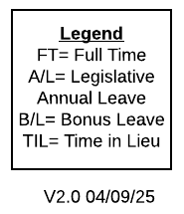
The written Bonus Leave Scheme Policy & Procedure 2026 v1.0 (effective 08/09/2026) says more than the flowchart does, and in four places it would give a different result. I have listed them below with the two documents side by side and what the tracker does, so you can confirm the flowchart is the version we work to, or tell me the policy document overrides it.
1. Who is eligible
Flowchart v2.0: full-time employees only.
Flowchart v2.0
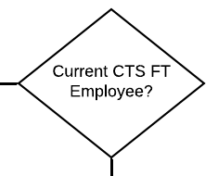
2026 policy: part-time employees on 24 or more hours a week are now eligible, from 5 years' service.
2026 policy, Scope (page 3-4)
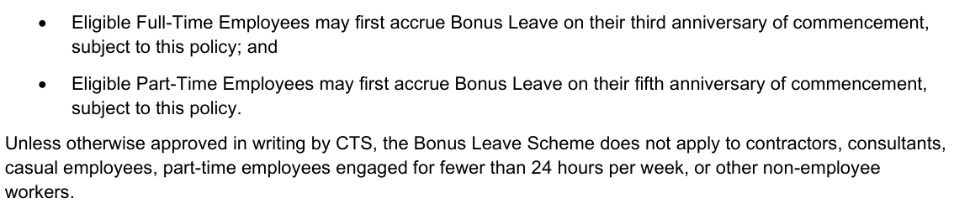
Tracker: full-time only, per the flowchart. Isaac Butterworth's part-time service from 17/09/2019 does not count; his full-time service runs from 19/01/2026 and his first day falls on 19/01/2029. Tyrell Shortt (part-time) is not eligible. The HR tally credited 9 days to Isaac and 1 day to Tyrell on a part-time basis, so those need reversing unless you decide the policy document applies.
2. The 5-year anniversary
Flowchart v2.0: one day on the anniversary, then one day every three months (two days only from the 6-year anniversary).
Flowchart v2.0, 5 years or more
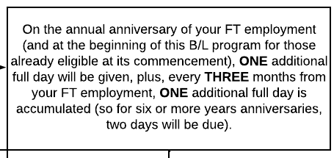
2026 policy: two days on the 5-year anniversary itself.
2026 policy, Accrual Rules (page 5)
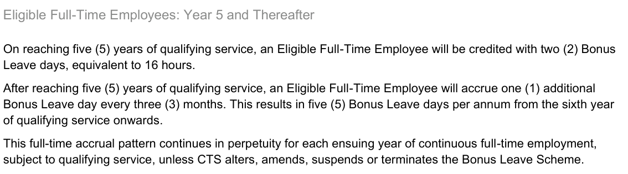
Tracker: one day on the 5-year anniversary, per the flowchart. This matches the HR tally.
3. Part-time accrual rate (new in 2026)
2026 policy, Eligible Part-Time Employees (page 5-6)
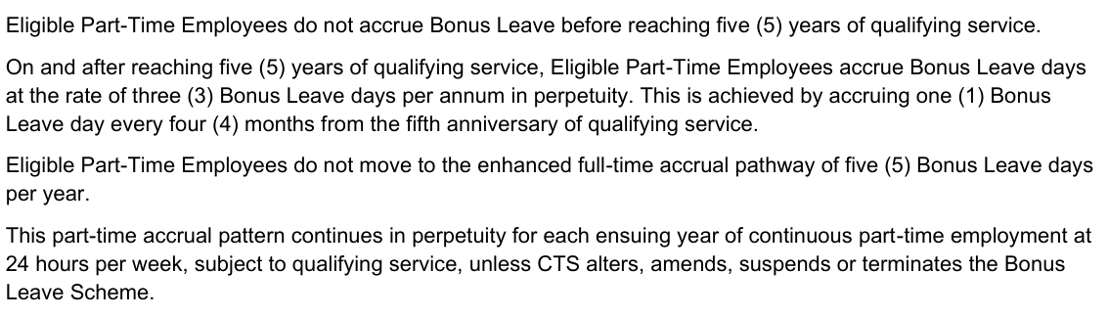
Tracker: not applied.
4. When service is counted from
Flowchart v2.0: from the full-time employment start date, or the eligibility letter date if different.
Flowchart v2.0, 3 to 5 years
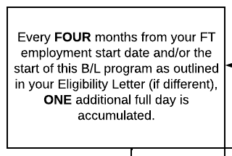
2026 policy: from the original start date with CTS, paused during parental leave or leave without pay.
2026 policy, Definitions (page 3)
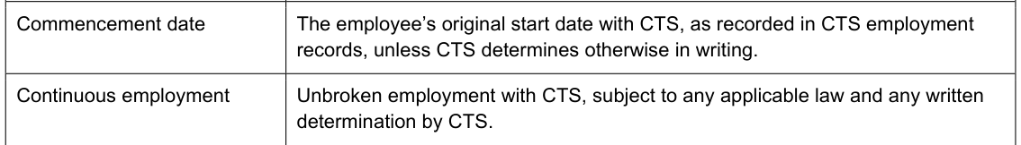
2026 policy, Qualifying Service and Extended Leave of Absence (page 5)
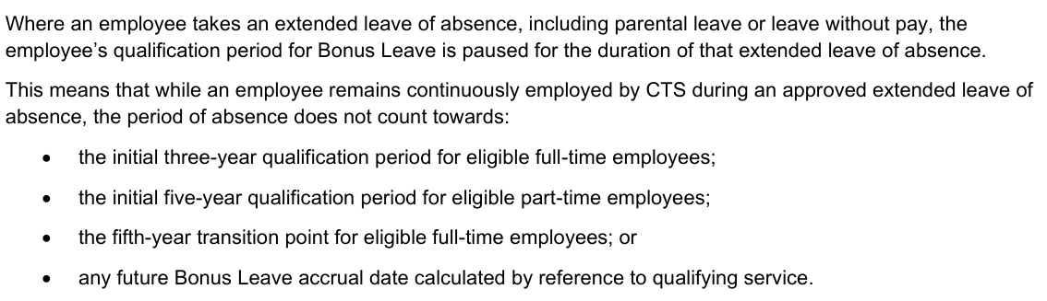
Tracker: service counts from the full-time start date (or the Eligibility Letter date if different), including service before 27/11/2017. Milestones that fell before the scheme start earn nothing; the first day is the first milestone on or after 27/11/2017.
On this basis Jordan Sexty's EH balance matches the scheme exactly. Duncan Lugstein holds 16 hours more than the scheme gives because HR ran his accruals on a Feb/May/Aug/Nov cycle instead of his October anniversary. Daniel Sobkowski is 104 hours under: the scheme gives him 43 days from 27/11/2017 but EH only holds 30. I checked Daniel's and Jordan's personnel files and could not find an eligibility letter for either of them.
5. Termination (the agreed change, already in v2.0)
Flowchart v2.0: all due entitlements including annual leave are paid out, Bonus Leave is not.
Flowchart v2.0, leaving CTS
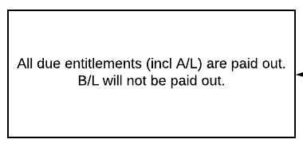
2026 policy: the same, all unused Bonus Leave is forfeited.
2026 policy, Termination of Employment (page 8)
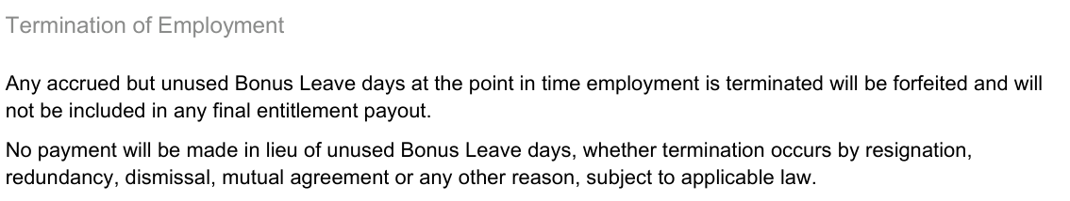
Tracker: leavers are removed and their EH balance zeroed.
Everything else is the same in both: first day at 3 years, one day every four months to year 5, five days a year after that, no pro-rata, and nothing before the scheme start on 27/11/2017.
Flowchart v2.0, yearly rates
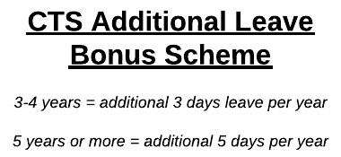
Decisions I need from you: (1) confirm the flowchart v2.0 is the version we work to, or tell me the 2026 policy document overrides it (part-time eligibility and two days at 5 years), in which case I flip one switch in the tracker and Isaac and Tyrell come back on; (2) whether the 16 hours Duncan is over stands, and whether I post the 104 hours owed to Daniel; (3) whether the 9 days for Isaac and 1 day for Tyrell on the HR tally are reversed. The eligibility letters I listed in my earlier email still stand, with Isaac and Tyrell removed from that list under the flowchart.
Thanks,
Danica

